## Overview

CSS Grids can be used to build simple and skeletal layouts. It can also be used to create polished, professional-level layouts.

In this activity, you will use CSS Grids to re-create the design of an online furniture store.

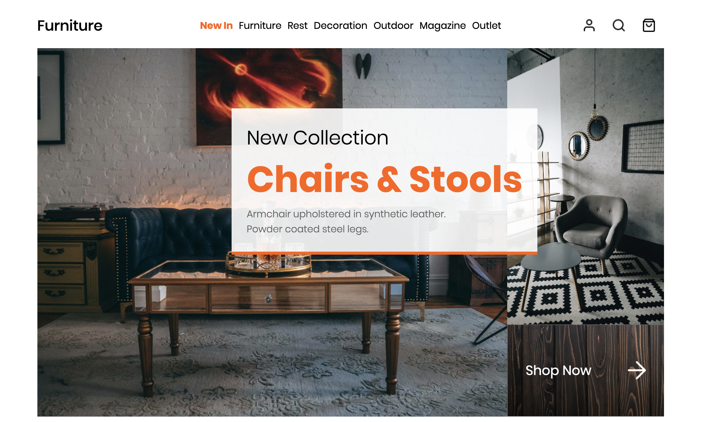

## Instructions

1. In Visual Studio Code, open the files <>index.html and # style.css.
   * The files are located in the Activities folder in the .zip file: 18.2-activities.zip > furniture_landing_page > unsolved files.
   * You’ll notice that the HTML and CSS for the navigation bar code have already been completed along with some typography-related CSS.
2. The HTML for the grid in the image at the beginning of this activity has already been completed. Review the HTML structure below.  
   *\* Students, make sure you review the index.html activity as you write your CSS selectors.*  
   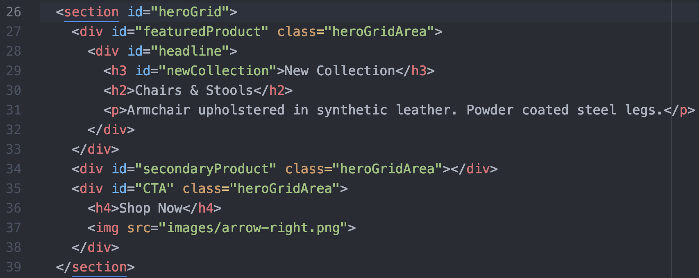

**Step 1: Define the Grid**

1. In style.css, locate a selector that targets the heroGrid ID.



* + Add the following properties to define the overall size of the grid:

|  |  |
| --- | --- |
| **Property** | **Value** |
| margin | 0px 5% |
| display | grid |
| min-height | 500px |
| height | 70vh |

Now that you have sized the CSS Grid, it’s time to add more CSS properties. Use the grid-template-rows:, grid-template-columns:, and grid-template-areas: properties to create the structure of the CSS Grid.

1. The #heroGrid ID at the top of the page has two rows andtwo columns.
   * The first row and first column each occupy 75% of their respective areas.
   * The second row and second column each occupy the remaining 25% of their respective areas.
   * Use the values above for the grid-template-rows: and grid-template-columns: properties.

*CSS hint: Do not use commas between percentages.*

Hero grid layout visual:

|  |  |  |  |
| --- | --- | --- | --- |
|  |  |  |  |
|  | **featuredProduct** |  | **secondaryProduct** |
|  |  |  |  |
|  | **featuredProduct** |  | **CTA** |

1. Next, add to your CSS. #heroGrid{ grid-template-areas: }*.*

*Hint: The featuredProduct, occupies the top and bottom left areas, the secondaryProduct, is in the top right and the CTA is in the bottom right.*

**Step 2: Add Content to the CSS Grid**

HTML reference:

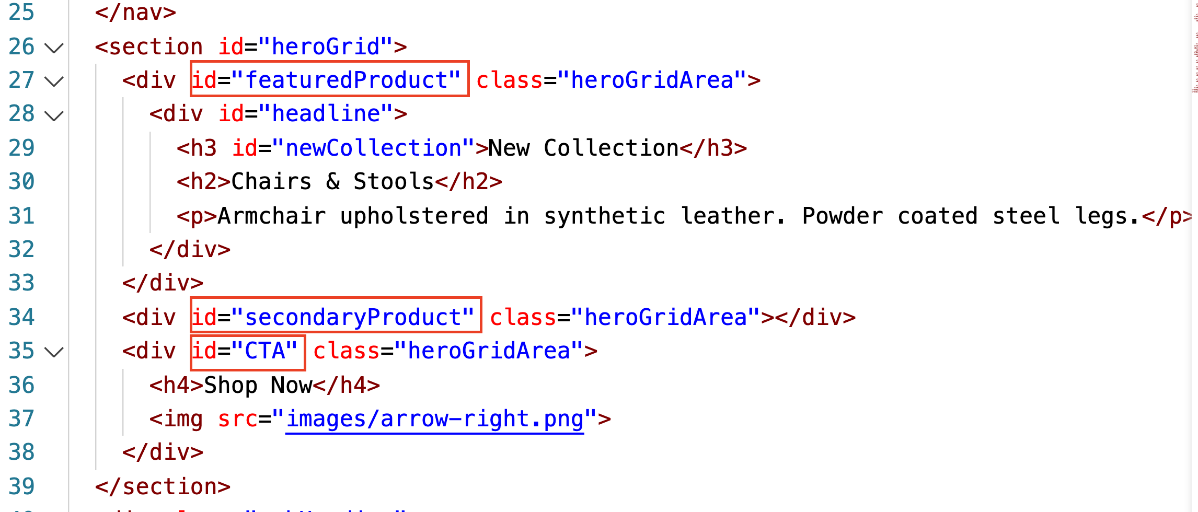

1. Create three CSS selectors that target the IDs of each area within the grid from the HTML: featuredProduct, secondaryProduct, and CTA.
   * Within each selector, define the value for the grid-area: property so that each CSS selector and the CSS contained within it is associated with the correct area within the grid.

*Hint: Spelling and capitalization in the syntax matter here, so pay attention.*

1. Add a background-image: to each .heroGridArea class selector using the images provided in the images folder.
2. Add the following properties and values to the #CTA ID selector:
   * These will be used to style content within this grid area.

|  |  |
| --- | --- |
| **Property** | **Value** |
| justify-content | space-around |
| cursor | pointer |

1. Notice the repeated .heroGridArea class on each grid area in <> index.html. You can use CSS to target all instances of that class and style each instance the same.
   * Create a CSS selector that targets the .heroGridArea class and add the following CSS properties:

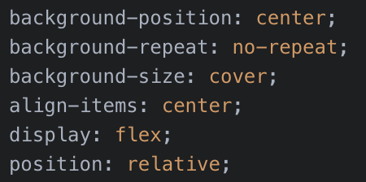

**Step 3: Add Finishing Polish**

1. If you were to open <> index.html in your browser, it would almost look complete except for the fact that the headline <div> isn’t in the right place.
2. In order to align the headline <div>, add a border-bottom: 5px solid #FF6200;.
3. Next, add a transparent background-color:.
   * You could do this with a transparent image or you can use the rgba() function to define red, green, blue, and alpha (opacity) values for a color.
   * Set the value for background-color to rgba(255,255,255,0.8);.
   * This will set the background color to white at 80% opacity.
4. Position the headline <div> so that it’s floating above and between the featuredProduct and secondaryProduct grid areas.
   * *Hint:**You will need to use position: absolute; along with top and right values to achieve this.*
5. Lastly, add a z-index value to move the headline <div> above its parent and then add padding to create some spacing.
6. Now, finally, open index.html in your browser.
7. You should see your final result—the grid you just built!

Hero space should look like this:   
